|  |  |  |
| --- | --- | --- |
| IICT ASSIGNMENT 2 | December 14  2019 | |
| CLASS=1A  NAME=POORAB GANGWANI  ROLL NUMBER=CS191092 | | DHA SUFFA UNIVERSITY |

**USES OF VIRTUAL REALITY**

MILITARY

VIRTUAL REALITY HAS , IN RECENT YEARS, CHANGED THE VERY TRAINING AND COMBAT STRUCTURE IN THE MILITARY AS NOW THE US GOVERNMENT HAS INITIATED UTILISATION OF VR TECHNOLOGY IN THE DEVELOPMENT OF A MASSIVE VR BATTLEFIELD TO PHYSICALLY AND MENTALLY PREPARE NEWCOMERS TO NOT ONLY GAIN MORE EXPERIENCE OF HOW IT IS LIKE TO BE IN THE THEATRE OF WAR BUT THROUGH IT ALSO UNDERSTAND THE NEED FOR EFFICIENT STRATEGIC THINKING ON THE BATTLEGROUNDS . (ROBITZSKI, 2019)

EDUCATION

VIRTUAL REALITY AFTER IMPLEMENTATION INTO THE EDUCATIONAL SPHERE HAS CREATED NEW WAYS AND METHODS TO LEARN AND TEACH THAT HAVE NOT ONLY INCREASED THE EFFICIENCY OF TEACHING BUT ALSO HELPED INTENSIFY THE DESIRE OF STUDENTS TO LEARN AND SOME OF THE EXAMPLES OF VR IN EDUCATION ARE THE TELEROBOTICS IN WHICH CHILDREN CAN LEARN TO PROGRAM A ROBOT TO PERFORM AND THROUGH THE USE OF VR ,CHILDREN CAN HAVE FIRST PERSON EXPERIENCE OF ALL THE FAMOUS OCCURANCES TAUGHT IN HISTORY AND THIS APPROACH ALSO APPLIES TO OTHER SUBJECTS AS WELL.(Uses of Virtual Reality in Education, 2018)

HEALTHCARE

VR IN HEALTHCARE HAS NOW EQUIPPED DOCTORS TO TRAVEL INTO THE BODY AND REACH PLACES PREVIOUSLY IMPOSSIBLE TO REACH AND IT’S ADVANTAGES ALSO APPLY TO MEDICAL STUDENTS AS NOW INSTEAD OF BEING DEPENDENT ON CADAVERS,NOW MEDICAL STUDENTS CAN PRACTICE AND LEARN SURGERY.VR HAS ALSO HELPED IN THE CURING OF PSYCHOLOGICAL AILMENTS LIKE PTSD AND OTHER ILLNESSES LIKE MEMORY LOSS AND HAS ALSO HELPED IN CREATING AWARENESS OF THE DIFFICULT LIFE OF PATIENTS SUFFERING FROM CERTAIN DISEASES LIKE PARKINSONS THROUGH A VR HEADSET WHICH THEN HELPS GET A FIRST PERSON EXPERIENCE OF THE DISEASE FROM IT . (Virtual Reality in Healthcare)

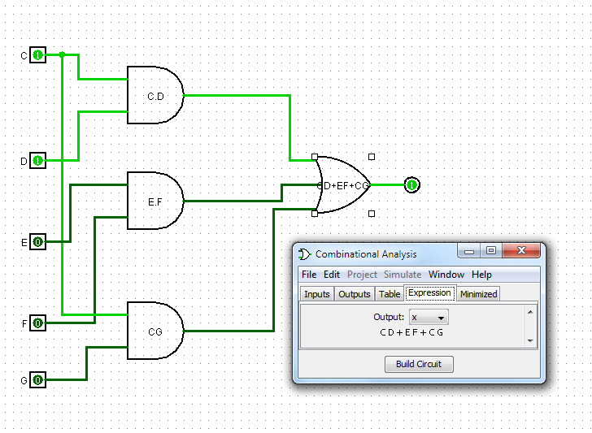

We only need three 2-input ANDS and one 3-input OR to realize

C.D + E.F + CG

WEBPAGE LINKS

# Bibliography

ROBITZSKI, D. (2019, MARCH 22). *The U.S. Army Is Using Virtual Reality Combat to Train Soldiers.* Retrieved from futurism: https://futurism.com/army-soldiers-vr-combat-training

*Uses of Virtual Reality in Education.* (2018, OCTOBER 17). Retrieved from crissh: https://www.crissh2020.eu/uses-of-virtual-reality-in-education/

*Virtual Reality in Healthcare.* (n.d.). Retrieved from visualise.com: https://visualise.com/virtual-reality/virtual-reality-healthcare